

Software Engineering Assignment

Module: 1

SE------ 0verview of IT industry

1.) what is software? What is software engineering? Ans:

Software:

* A software is a set of instruction, data or programs Used to operate computers and execute specific tasks
* **Software is a generic used to refer to applications, scripts and program that run on a device**

**Software engineering:**

* **Software engineering is the branch of computer science that deals with the design, development, testing and maintaining software**
* **Software is a collection of programs is. And that program is developed by software engineers**
* **The code of the program is written in many languages such as C++, java, python, Django, etc.**

**2.) Explain types of software?**

**Ans: there are two main categories of software are application software and system software.**

**Application software:**

* **An application software is a type of computer program that performs a specific personal, educational, and business function.**
* **Application software programs are created to help with a wide range of tasks. Here are few examples:**
* **Information on data management.**
* **Development of visuals and video.**
* **Management of accounting, finance, and payroll.**
* **Management of business process.**
* **Emails, text messaging, audio, and video conferencing, and cooperation are all points**

**System software:**

* **Software that provides a platform for other software. Some examples can be operating systems, antivirus software, disk formatting software, computer language, etc.**
* **System software is a type of computer program that is designed to run a computer’s hardware and application programs.**
* **Operating system (OS): windows, Linux, macOS, etc.**
* **Device drivers: software that enables communication between hardware and OS.**
* **Firmware: pre-installed low-level software that controls device basic functions.**
* **Utility software: tools for system maintenance and optimization**
* **Boot leaders: software that initializes the OS during startup.**

**3.) What is SDLC? Explain each phase of SDLC?**

**Ans:**

* **Software development life cycle (SDLC) is a structured process that is used to design, develop, and test good quality software.**
* **SDLC is a methodology that defines the entire procedure of software development step by step**

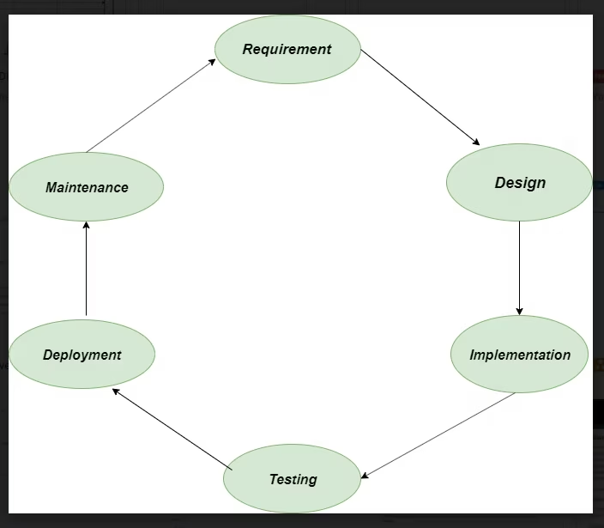

* **Phases of SDLC:**
* **Requirement gathering and analysis: this phase involves gathering information about the software requirements from stakeholders, such as customers, end-users, and business analysts.**
* **Design: in this phase, the software design is created, which includes the overall architecture of the software, data structure, and interface.**
* **It has two steps:**

**1.) High-level design (HLD): it gives the architecture of the software products**

**2.) low-level design (LLD): it describes how each and every feature in the product should work and every component.**

* **Implementation: the design is then implemented in code, usually in several iterations, and this phase is also called Development.**
* **Testing: The software is thoroughly tested to ensure that it meets the requirements and works correctly.**
* **Deployment: After successful testing, the software is deployed to a production environment and made available to end-users.**
* **Maintenance: This phase includes ongoing support, bug fixes, and updates to the software.**

**4.) What is DFD? Create a DFD diagram on Flipkart?**

**Ans: DFD stands for Data Flow Diagram, which is a graphical representation of the flow of data through a system or process. It illustrates how data is input into the system, processed, and outputted to other components.**

**Creating a DFD for Flipkart, an e-commerce platform, would involve identifying the main processes and data flows within the system. Here's a simplified DFD diagram for Flipkart:**  
 | Flipkart |  
 +-------+-------+

***DFD stands for Data Flow Diagram, which is a graphical representation of the flow of data through a system or process. It illustrates how data is input into the system, processed, and outputted to other components.***

***Creating a DFD for Flipkart, an e-commerce platform, would involve identifying the main processes and data flows within the system. Here's a simplified DFD diagram for Flipkart:***

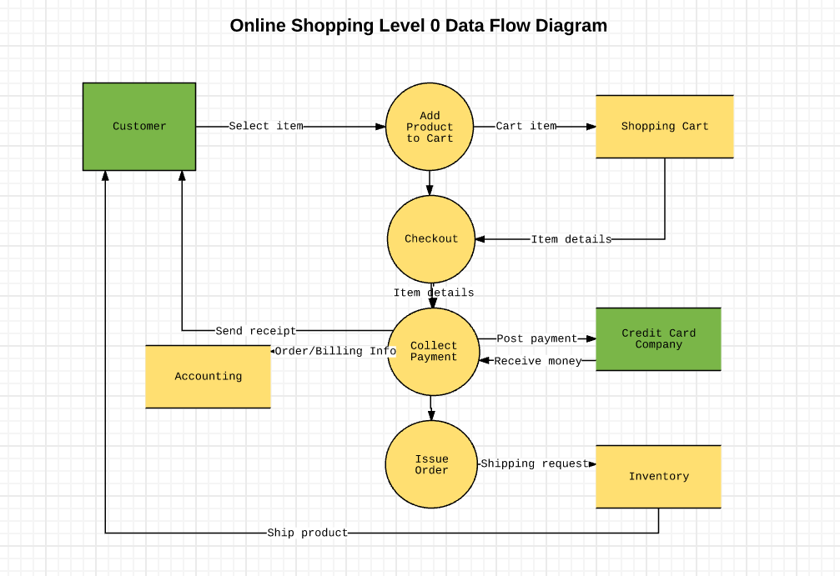

***In this diagram:***

* ***Customer: Initiates the process by browsing products, adding them to the cart, and placing orders.***
* ***Flipkart: Manages the overall system.***
* ***Product Database: Stores information about the products available on Flipkart.***
* ***Payment Gateway: Handles payment processing for orders.***
* ***Order Processing: Manages order fulfillment, including processing orders and updating order status.***
* ***Shipping Service: Manages the shipment of orders to customers.***
* ***Inventory Management: Tracks inventory levels and updates product availability.***
* ***Customer Support: Provides support to customers regarding their orders, products, or other inquiries.***

***These components interact with each other through data flows, representing the flow of information and data between them.***

***5.)*** ***What is Flow chart? Create a flowchart to make addition of two numbers***

* ***A flowchart is a type of diagram that represents a workflow or process. A flowchart can also be defined as a diagrammatic representation of an algorithm, a step-by-step approach to solving a task.***
* ***A flowchart (or flow chart) is a diagram that shows the steps in a process.***
* ***Flow charts are often used for visualizing the sequence of action or information needed for training, documenting, planning, and decision-making.***
* ***They often use symbols, shapes, and arrows to illustrate how one step leads to another.***

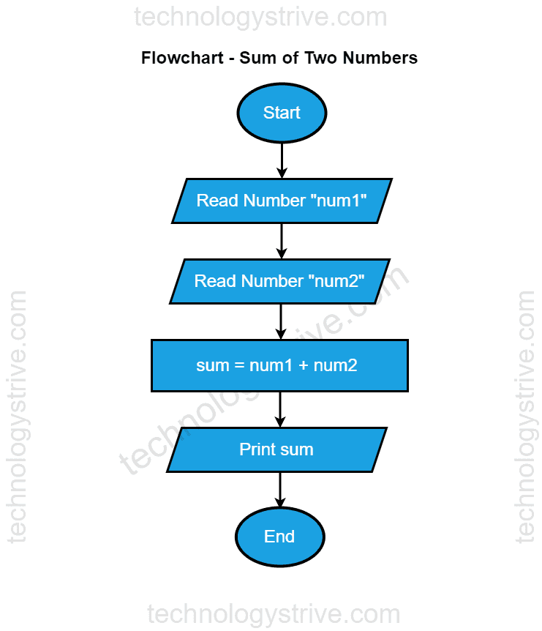

***6.) What is a Use case Diagram? Create a use-case on bill payment on Paytm.***

* ***A use case is a written description of how users will perform tasks on your website. It outlines, from a user's point of view, a system's behavior as it responds to a request. Each use case is represented as a sequence of simple Steps, beginning with a user's goal and ending when that goal is fulfilled.***
* ***There are various components of the basic model:***

***1.) Actor***

***2.) Use case***

***3.) Associations***

